Multi-Class Liver Cancer Classification using Multiple Deep learning Neural Networks

Dawood Ahmed
The Superior University, Lahore. dawoodahmedbsit@gmail.com
Zainab Fatima
The Superior University, Lahore. zainabranjha96@gmail.com
Arooba Sultan Tiwana
University of Sargodha. aroobasultantiwana@gmail.com
Fareeha Batool
The Superior University, Lahore. fareehabaloch29@gmail.com
Anam Safdar Awan
The Superior University, Lahore. anamawan416@gmail.com
M. Shahid Mehmood
The Superior University, Lahore. shahidkhan.ak16@gmail.com
A B S T R A C T

Cancer remains a garnering a prominent position among the deadliest illnesses worldwide. This condition is defined by the uncontrolled proliferation of the body’s cells. Such diseases invade almost all body organs including the liver. Liver cancer can be categorized into primary and secondary types. The primary liver cancer types are cholangiocarcinoma and HCC, both of which are primary liver cancer types. The newest and one of the most prominent types of liver cancer is hepatocellular carcinoma. This cancer type is most associated with the liver and is derived from its various cellular components. Metastasis is a type of secondary liver cancer that occurs when a malignant tumor is formed from any body region and specifically targets the liver. The presence of liver tumors signifies a critical point in cancer evolution; however, the prognosis is much better when liver lesions are detected in the early stages. This study seeks to address the burning issue of early detection and the subsequent treatment of liver cancer. We propose the application of modern deep learning methods to automatically identify lesions deemed cancerous on the liver. This study focuses on the application of Deep Learning, and more specifically, CNNs, and their impact on the accuracy and the quality of diagnosing liver cancer. One of the approaches includes training a CNN to identify primary liver tumors on MRI scans, CTs and Ultrasounds. This study documents the techniques in training the model to detect and contour the liver cancer. This step involves the application of image preprocessing and the training of the neural networks on the extracted features of the liver cancer images... Then, a variety of Deep Learning and other Shallow Learning techniques are used and compared based on system performance to the defined metrics of accuracy, precision, recall and the F-measure. The accuracy of the proposed computer-aided diagnosis system is 95%, the precision is 96%, and the system retains a 95% recall and F1 score. The proposed system outperforms other deep learning models which were ‘fine-tuned’ using ‘transfer learning’.
INTRODUCTION
The liver plays a vital role in physiology. It is situated on the right-hand side of the abdomen; It is sub-diaphragmatic and supra-stomach. The liver sifts the blood and in the process extracts and keeps some useful constituents of it. It also synthesizes some proteins, blood coagulation factors, and cholesterol. Some abdominal derangements of the liver also generates and produce albumin which stabilizes the blood cholesterol level and lipoproteins (Alberts, et al. 2002).
Cancer is a multitude of diseases which, unfortunately, happens to be the second leading cause of death in the world (WHO, 2022). It is a chronic and multifaceted ailment that infests the body with a multitude of the body’s cells which begin to uncontrollably and wildly flourish. These cells tend to cluster, forming a mass known as a tumor. The tumor is able to aggressively proliferate, invade and metastasize to far off areas of the body. The World Health Organization stated that in the year 2015, from the 8.8 million deaths caused by cancer, 788,000 of them were because of liver cancer. In 2017, it was estimated by the American Cancer Society that 40,710 new cases of liver cancer would be diagnosed in the United States.
The WHO updates indicate that a total of 28,920 deaths occurred in 2020, with the majority attributed to primary liver cancers and cancers of the intrahepatic bile ducts. There were 19.3 million new cancer cases diagnosed in the same year, and the Wh0 estimates that There were approximately 10 million cancer-related deaths in 2020.
Different kinds of cells in the liver may give rise to malignant and benign tumors. Liver cancer is the most common cause of cancer death in the world. The liver is in contact with many organs, and liver cancer may be of two main types: primary liver cancer, which starts from different kinds of cells in the liver and secondary liver cancer, which is due to the spread and rapid growth of cancer from distant organs. An image of cancerous cells in the human liver which often results in severe complications.
Types of Liver Cancer
Primary and Secondary are the two kinds of liver cancer. Two distinct kinds of primary liver cancer include cholangiocarcinoma and HCC [8]. Liver tumors are divided into distinct types depending on the impacted cells. The various kinds of liver cancer are:

Hepatocellular Carcinoma
Primary liver cancers remain highly diagnosed the world over. Hepatocellular carcinoma (HCC) is the most common in this region. HCC comprises about 80% to 90% of the primary liver cancer malignancies while cholangiocarcinoma covers 10% to 15% of the margins. Indications show that the emergence of primary liver cancer has worsened over the years. Recently the WHO has filleted that over 1.2 million people will lose their lives to liver cancer by 2040. The rates of primary liver cancer differ radically in some regions of the world. In rare cases, a primary liver tumor is diagnosed, and over time as it advances, the rest of the body becomes involved. This has also been referred to as metastasizing. In a sclerosed liver, and in HCV and HBV infections, these patients most commonly develop hepatocellular carcinoma. The absence of symptoms in the earlier stages is a prominent cause of this oversight.
On the other hand, particularly advanced stages of cancer may also manifest certain symptoms such as, but not limited to, excessive fatigue, continuous abdominal pain and/or swelling, persistent vomiting, and even an unexplained loss of appetite, as well as weight, and an unusual degree of bleeding and/or bruising. The primary liver cancer stage is particularly problematic owing to its intrinsically quiet nature. The absence of clinically useful early detection methods, scant symptoms, and intricate restrictions surrounding treatment rationalization, lie at the core of such problems. Primarily, marked improvements in primary liver cancer management prognostics hinges on regular screenings of high-risk populations and early cancer detection methods. Meanwhile, secondary liver cancer is the result of a distant malignancy liberally migrating towards the liver. Figure 1.2 illustrates the difference between a cancerous liver and a healthy one.

Cholangiocarcinoma
Cholangiocarcinoma (bile duct cancer) is a rare and immensely aggressive form of cancer which occurs within the bile ducts. These are thin tubes which convey bile from the liver and gall bladder to the small intestine. It is termed extrahepatic cholangiocarcinoma when it arises from the bile ducts outside the liver. Intrahepatic cholangiocarcinoma (ICC) pertains to bile duct cancer arising within the liver. ICC is a subclass of primary liver cancer and is a form of ICC. It encompasses the intrahepatic bile ducts within the liver, the perihilar bile ducts adjacent to the liver, and the distal bile ducts near the small intestine.
For classification purposes, cholangiocarcinoma is integrated with intra and extrahepatic cholangiocarcinoma, as illustrated in the accompanying Figure-1.
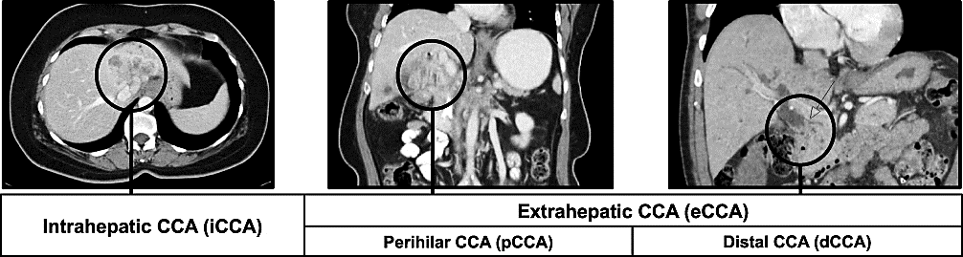
Figure 1-Classification of Cholangiocarcinoma

Hepatoblastoma
Hepatoblastoma is a form of liver cancer almost exclusively affecting younger children which most characteristically gets diagnosed under the age of 5. It is also the most common form of liver cancer occurring in this age group. This condition is still poorly understood, originating from immature liver cells called hepatoblasts. Birth complications such as premature and low-weight births as well as certain genetic disorders including the Beckwith-Wiedemann syndrome put children at increased risk of developing hepatoblastoma. Symptoms can include but are not limited to jaundice, abdominal pain and fullness, unexplained weight loss, loss of appetite, nausea, vomiting, fever, and abdominal fever. The treatment methods of hepatoblastoma often are centered around a multidisciplinary approach. This can include the surgical removal of a tumor through partial hepatectomy or even, in some cases, liver transplantation. In the context of hepatoblastoma, the tumor is most often the focus of chemotherapy before surgery in order to debulk the tumor, or to attack other cancer cells remaining after the surgery. It is also worth noting that in some cases, radiation therapy may also be needed. However, in young children this form of treatment is greatly restricted due to long-term affecting developing organs.
LITERATURE REVIEW
We thoroughly analyze the broad and multifaceted domain of classification algorithms from the angle of classical machine learning and deep learning. Prominent algorithms, for instance, Support Vector Machines, Random Forests, and Convolutional Neural Networks, are studied profoundly with their respective use cases, advantages, and downsides pertaining to the classification of liver cancer. The classification of liver cancer presented in the taxonomy below provides a skeletal outline which aids in the classification and systematization of the numerous components in the domain.
Aatresh et al. [27] pioneered a deep learning framework for the classification of multi-label tumor scans which proved to be much better in terms of processing time and attribute classification than other aggressive techniques. After a series of rigorous tests on the malignant scans, he set the architecture of LiverNet as the benchmark for future works in the field. For the performance metrics of the system, the accuracy is set to 90.93%, an F1-score of 0.9093, a precision and recall which is 0.9093 pertaining to the KMC data repository. The major concern of the framework which they studied remains the highly heterogenous dataset which comprised of several patterns and the specific nature of size.
Using transfer learning, Elbashir et al.[29] categorized the two main liver types, HCC, and lesion hemangioma, distinctively using ultrasound images. Their technique included using ensembles of the best deep transfer models from the existing models: DenseNet, ResNet, VGG16, Inception, VGG19, InceptionResNet, and EfficientNet. The authors achieved a test accuracy of 95% with recall, precision, and F1-measures echoing this result.
Zheng et al. [31] developed the 4D framework focusing on the use of 3D filtering and a specific type of CLSTM network to target the lesion diagnostics of HCC. This approach utilized the partitioning of liver malignancy 4D data from MRIs employing temporal contrast. Particularly, a 3D CNN module based on a CLSTM framework composed of 4 layers to exploit temporal information and spatial features within the 3D domain during each DCE step. This designed leverages a shallow U-net architecture and DCE phase extracted during the CLSTM framework. In this case, the 4 layers of the CLSTM framework aimed at optimizing and manipulating the temporal dynamics of the data. Considering the results, the suggested framework proved quite efficient, obtaining a recorded distance of 12.84 mm ±8.14 mm, a Dice score of 0.825 ±0.077, and volumetric similarity of 0.891 ±0.080 on the segmented malignant liver.
Almotairi et al.[34] developed a deep learning method for liver CT segmentation and classification from the semantic pixel-wise classification of road scenes technique. The architecture, SegNet, contained a deep convolutional encoder–decoder structure arranged hierarchically. In the training stage, the full evaluation on a standard liver CT scan dataset recorded a notable tumor accuracy of 99.9%. Li et al. [38] put forward a fully automated Computer-Aided Diagnosis (CAD) system that incorporated Convolutional Neural Networks (CNN) in the detection of HCC. The CAD system that was developed employed CNNs for automated segmentation and classification. HCC was diagnosed through a 9-layered convolutional neural network (CNN) classifier HCC after segmentation with Fully Convolutional Networks (FCN) augmentation with the original CT scan and classification of the 4-channel images. The classification accuracy for the CNN classifier attained was 98.4%.

Table 1: Work On Liver Cancer Classification
Reference | Year | Technique | Dataset | Use/Purpose | Accuracy(%)
[25] | 2021 | GoogleNet | HCC Liver Image Dataset | Used for classification of HCC histopathology images | 91.37
[26] | 2023 | Hybrid CNN | CT images of Liver | Used for multi-class categorization of the identified tumors | 87.8
[27] | 2021 | LiverNet | KMC dataset and TCGA- Liver dataset | Used for the multi-class cancer classification of liver HCC tumor histopathology images | 90.93
[28] | 2024 | ULM-net | 3DIRCADb, MICCAI 2017 LiTS Challenge Dataset | Used for liver tumor segmentation and classification | 99.3
[29] | 2023 | Transfer Learning | Dataset collected from different sources | Used to categorize the liver into two primary types | 95
[30] | 2023 | Inception-V3 | Multi-institutional independent dataset | Used for categorization of HCC, ICC, CRLM, and benign tumors | 96
[32] | 2020 | CNN | HCC dataset | Used to identify and categorize HCCs | 90
[38] | 2020 | CNN | CT scans | Used to categorize HCCs | 98.4
[39] | 2024 | LivlesioNet, MMS, BS | CT scans | Used to identify HCCs | 97.7
[40] | 2024 | LiverNet2.0,LiverNet2.1 | KMC Liver Dataset, TCGA Liver Dataset | Used for the classification of hepatic tumor | 97.50 of LiverNet2.0,  97.14 of LiverNet2.1

Related Techniques
Hussain et al.[41] discussed various artificial ROIs used to classify liver cancers by applying different ML methods: J48, RT, LMT, and RF. The tumor types in the dataset included metastasis, hemangioma, HCC, and cyst. To enhance the classification process, a CFS approach was used to extract 20 optimized features from an initial 55 feature set. The outcomes achieved by RT and RF were superior to those achieved by J48 and LMT, with the former claiming the highest accuracy of 97.48% and the latter attaining an accuracy of 97.08%.
Naaqvi et al. [6] split the architecture for malign region segmentation within CT scans through an approach based on thresholding. Furthermore, the U-Net model was used in conjunction with Google-Net in order to classify liver malignancies. The used set in the selected technique was 3D-IRCADb01, which contains CT scans of patients with malignant tumors. Importantly, the U-Net model achieved the highest accuracy among the other models with 98.5% accuracy, 99.5% recall, 0.83 Dice Similarity Coefficient, and 98.75% F1 score.
Bhimavarapu [43] proposed a hyper tangent FCM technique for inter active segmentation of liver images, and precise classification of liver tumors in CT images. The investigation improved the classification accuracy on the linear mapping problem by augmenting it with fuzzy logic, which decreased the time and improved the accuracy for early diagnosis of liver disease. The model achieved increased classification accuracy with a marked improvement of 99.58%, while the time taken for liver tumor classification was reduced by 2-25 seconds.
Naeem et al. [45] used a fused approach to CT and MRI scans and developed an automated technique to detect liver tumors. The dataset was tested on MLP, SVM, J48 and RF classifiers. The MLP classifier achieved an accuracy of 95.78% in distinguishing six types of liver tumors using a ten-fold cross-validation approach.
METHODOLOGY
An approach utilizing deep learning methodologies for classifying liver cancer through automated processes was devised. Prior to the commencement of the implementation phase, several activities were undertaken: reviewing background literature, curating data, constructing the theoretical framework, devising outcomes, performing results analysis, and drawing conclusions. This research framework and the approaches to preprocessing, the description of dataset segmentation and evaluation of performances data using CNN models will be covered in the outline of this chapter.
• Acquire authentic data of liver cancer through sources such as Robo and tailor the dataset accordingly.
• From the dataset, extract multi-classes which contain ballooning, steatosis, inflammation, hepatocellular carcinoma, ballooning steatosis, and fibrosis.
• Prepare the dataset through noise removal, image resizing and image normalization.
• Organize the dataset into training, validation, and testing.
• String the models with the DenseNet121, ResNet50, and MobileNetV3 Models.
• Enhance and train the CNN model to increase results.
• Analyze the proposed model with chosen pre-trained models to assess outcomes.
• Assess the model in respect to proposed performance indicators such as Accuracy, Precision, F-1 Score, and Recall. Assess the performance of the Proposed Model along other selected pre-trained CNN Models and conclude the one that performs best. Performance evaluation of the proposed model using different performance valuation measures such as Accuracy, Precision, F-1 Score, and Recall.
- Compare the presentation of the Proposed Model with pre-trained selected CNN Models and identify the model with the best performance
Dataset Review
For our research, we initially acquired the liver cancer data from reliable sources such as Robo which provides standard datasets. Then we customized the dataset to fulfill our research requirements. The dataset contains six classes including hepatocellular carcinoma, ballooning, inflammation, steatosis, fibrosis, and ballooning steatosis. The allocation of images in the classes of our dataset is shown in Table below
Table 2: Image Distribution in the Liver Cancer Dataset
Class Name | No of images (30% for Testing)
Ballooning | 1032
Fibrosis | 1101
Inflammation | 1002
Steatosis | 1119
Ballooning Steatosis | 903
Hepatocellular Carcinoma | 972
Total | 6129
Feature Extraction and Classification
Feature extractors assist in differentiating characteristics in medical images to facilitate the decision-making processes pertaining to differentiating conditions for various tissues. Feature extraction can be done in the spatial or spectral domain. After the extraction there usually severl distinct features and the need to select the necesary focused features. Features are classified to determine the function performed on the object. With regard to classification, the retrieved and selected features are divided into distinct groups. This process may be classified into supervised and unsupervised. Features are divided into known classes in supervised and unknown in unsupervised. The classifier requires training and test input to measure the accuracy of its estimation and improve its decision-making efficiacy. Documented guidelines assist in medical image training and labeling validation for a collection of items performed and supervised by one or more domain experts. We will apply deep learning methologies in feature extraction and classification. This study employed deep learning CNN based classifier for feature extraction.

ResNet50
The term ResNet is an acronym for residual network. It was introduced by some researchers from Microsoft in 2015. The most popular architecture in the ResNet family is ResNet50 which was designed by Kaiming He and his collaborators. It consists of 50 layers and is particularly famous for eliminating the gradient problem and helping make training deep networks feasible. This model is extensively used for image classification and object detection.
Dense Net 121
DenseNet121 is a particular variety of DenseNet architecture in which every layer within a dense block profits input from all the previous layers. This model is designed to improve efficiency and reduce the overfitting issue. The model consists of 121 layers and it is widely used in image classification tasks.

Mobile Net V3
MobileNetV3 is the most topical version of MobileNet architecture and it is especially used for tasks including image classification as fit as object detection. This model is the expansion of the architectures MobileNetv1 and MobileNetv2 which is used to optimize the resource efficiency along with its performance.

Proposed CNN Model
The Convolutional Neural Network will be discussed in the proposed model. CNN is the deep learning model which is used to identify patterns and recognize features from visuals. It is mainly used in image classification and medical image analysis due to its accuracy. It is also referred to as Convnet. This model’s advantage is that it can recognize the important features without any human intervention. The proposed convolutional neural network has three layers and is outlined as follows:
Convolutional Layer
Continuing with the convolutional architecture detailed previously, the setup employs the VGGNet architecture. The initial sequence involves two convolution operations, each employing 64 filters, follows the sequence of layers 2, max-pool with 2x2 filters and 2 stride, and then 2 convolutions sequence of layers with 128 filters, with ReLU steered. The next sequence of layers, which consist 3 convolutions, with 256 filters, of 3x3 convolutions with the same stride, leads into a pooling operation. The next block consists of 3 convolution layers with 512 filters of the same 3x3, ReLU and stride 1, and convolutions, and then more pooling, to then be followed convolution layers with 512 filters of same. The sequence of layers, which consist of 3 new fully connected layers, and with differing amounts of units which sequentially decrease, passes the input into each with ReLU to ensure the needed activation with 4096 units, and the last with 1000. Additional layer of 0.5 dropout may be used, primarily after the fully connected layers to reduce the flow of active units and improve the generalization and avoid overfitting.

Pooling Layer
The pooling layer is the next layer followed by the convolutional layer. This layer aims to minimize the size of the feature map which can lower the computational cost. There are various types of pooling operations including max pooling and the average pooling. The pooling layer is a sort of bridge between the FC layer and Convolutional.

Fully Connected Layer
The next layer after pooling is a fully connected layer where interlayer connectivity is established. In this layer, the output images from the previous layer are being transformed into a flat structure (“flattened”) and then provided to the FC layer. A crucial characteristic of a CNN model is the non-linear activation functions which purpose is to increase the network's nonlinearity. ReLU and Softmax are the most popular activation functions. Softmax is used when the problem involves multiple classes to be classified. In this case, ReLU and Softmax were used as the CNN’s activation functions.
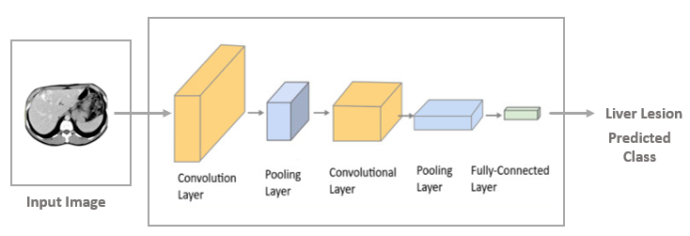
Figure 2 Architecture of CNN Model
RESULTS AND DISCUSSION
In this section, we will explain all the pre-trained models that we have applied to the selected dataset. Each pre-trained model yields a different outcome. We have implemented DenseNet121and ResNet50 pre-trained models. All these pre-trained models are implemented on same number of epochs. The loss function and batch size were kept the same throughout the training and testing phases of each pre-trained model. After conducting training and validation on the identical dataset, we computed accuracy, loss function, precision, recall, and F-score for each pre-trained CNN model. Here we will analyze and compare the outcomes of each pre-trained model.
- DenseNet121
This pre-trained model was implemented on the selected dataset for 100 number of epochs using a learning rate of 0.00001 and batch size of 32. Accuracy, precision, loss, and recall are computed. Figure 4.1 demonstrate the visual representation of loss obtained by DenseNet121 model.

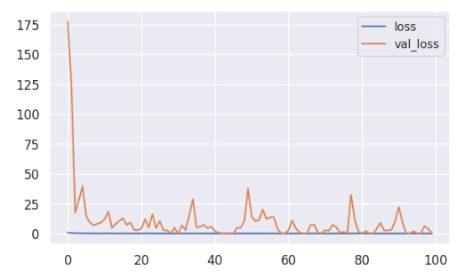
Figure 3: Loss obtained by DenseNet121 Model
Similarly, figure 3 exhibit the visual representation of accuracy obtained by DenseNet121 model.
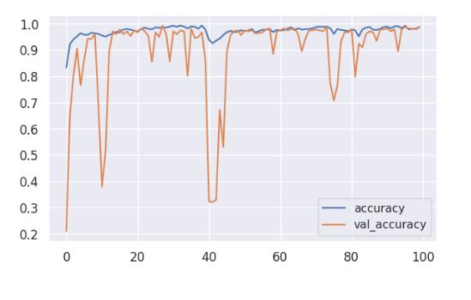
Figure 4: Accuracy obtained by DenseNet121 Model
Similarly, figure 4.3 represent the visual representation of confusion matrix for DenseNet121 model .
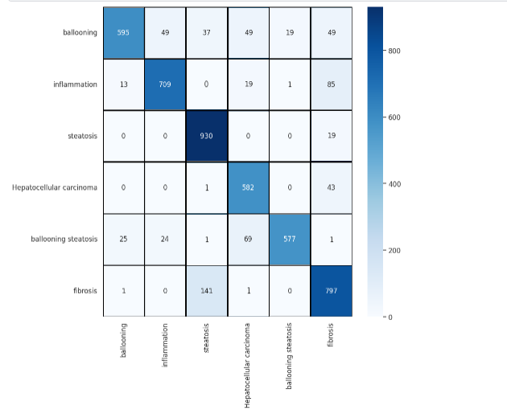
Figure 5 Confusion Matrix for DenseNet121 Model
The classification report of DenseNet121 model can be shown in Table 4.1.
Table 3: Classification Report of DenseNet121 Model
Classes | Precision(%) | Recall(%) | F1-score(%)
Ballooning | 98 | 86 | 92
Inflammation | 100 | 88 | 94
Steatosis | 100 | 43 | 61
Hepatocellular carcinoma | 79 | 99 | 88
Ballooning Steatosis | 80 | 99 | 89
Fibrosis | 68 | 100 | 81
- ResNet50:
This pre-trained model was implemented on the selected dataset with a learning rate of 0.00001 and a same number of epochs and batch size. Performance measures are also computed for this model. Figure 4.4 represent the loss obtained by ResNet50 Model.
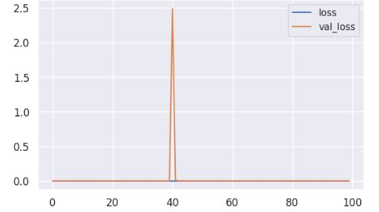
Figure 6 Loss obtained by ResNet50 Model
Similarly, figure 4.5 exhibits the accuracy obtained by ResNet50 model.
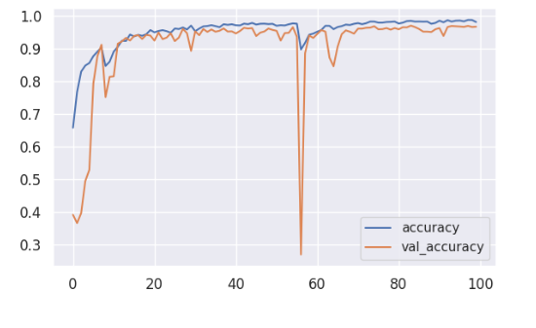
Figure 7 Accuracy obtained by ResNet50 Model
Similarly, the figure 4.6 represent the confusion matrix for ResNet50 model.
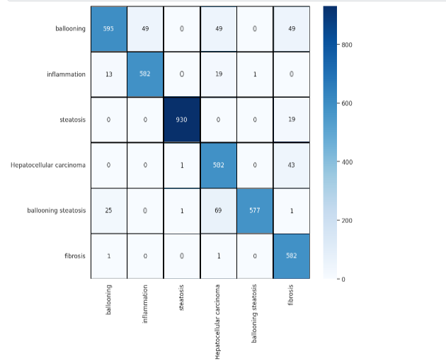
Figure 8 Confusion Matrix for ResNet50 Model
The classification report of ResNet50 model can be shown in Table 4.2.
Table 4: Classification Report of ResNet50 Model
Classes | Precision(%) | Recall(%) | F1-score(%)
Ballooning | 94 | 100 | 97
Inflammation | 100 | 39 | 57
Steatosis | 89 | 100 | 94
Hepatocellular carcinoma | 100 | 98 | 99
Ballooning Steatosis | 71 | 96 | 82
Fibrosis | 93 | 100 | 97
CONCLUSION
At first, the Robo platform was the source of the liver cancer dataset. It was refined thereafter to suit the purpose of the project. As for the dataset, it consists of 6 classes and 22379 images in total. After the dataset was assembled, a set of techniques for data preprocessing was applied for the purpose of the study. This set included the removal of redundant data and data enhancement. Following the preprocessing step, the model was featuring classified and relevant attributes extracted. Resting, training, and implementation was uniform for all models. A few also utilized pre trained models on the dataset of the other selected. Our study sitting multiclass liver cancer within the framework of deep learning is pivotal in relation to timely treatment and detection of the cancer. Our research was able to evidence deep learning methods in liver cancer diagnosis and the subsequent refinement to the perimeter of high precision. In the specific case, the framework is best suited to tackle the issue. Thus, a deep learning model was constructed from the CNN architecture with the primary aim of maximizing accuracy, in addition to other targeted performance metrics such as the f1-score, recall, and precision.
The improved performance of the model on the other pretrained models tested can be summarized in the 95% accuracy, 96% precision, 95% recall, and 95% f1-score results. The appropriate computational resources, along with the vast dataset, can be allocated for evaluation in the future. As has been seen in this and other studies, widening the frontier of data collection will be the first measure that needs to be taken to enhance visual quality in the models for future developments.
References
[1] J. D. L. Araújo et al., “An automatic method for segmentation of liver lesions in computed tomography images using deep neural networks,” Expert Syst Appl, vol. 180, Oct. 2021, doi: 10.1016/j.eswa.2021.115064.
[2] R. L. Siegel, K. D. Miller, N. S. Wagle, and A. Jemal, “Cancer statistics, 2023,” CA Cancer J Clin, vol. 73, no. 1, pp. 17–48, Jan. 2023, doi: 10.3322/caac.21763.
[3] F. Badar, M. Sohaib, S. Mahmood, O. R. Chughtai, F. Sultan, and M. A. Yusuf, “Cancer incidence in Khyber Pakhtunkhwa, Pakistan, 2020,” BMC Public Health, vol. 23, no. 1, Dec. 2023, doi: 10.1186/s12889-023-16686-5.
[4] U. Aeman, M. Kaleem, M. Sarwar, M. Azhar Mushtaq, S. Choudhary, and S. Rashid, “A Systematic Literature Review on Classification of Brain Tumor Detection”, doi: 10.56979/502/2023.
[5] A. Kaur, A. P. S. Chauhan, and A. K. Aggarwal, “An automated slice sorting technique for multi-slice computed tomography liver cancer images using convolutional network[Formula presented],” Expert Syst Appl, vol. 186, Dec. 2021, doi: 10.1016/j.eswa.2021.115686.
[6] Z. Naaqvi, S. Akbar, S. A. Hassan, and Q. Ul Ain, “Detection of Liver Cancer through Computed Tomography Images using Deep Convolutional Neural Networks,” in 2022 2nd International Conference on Digital Futures and Transformative Technologies, ICoDT2 2022, Institute of Electrical and Electronics Engineers Inc., 2022. doi: 10.1109/ICoDT255437.2022.9787429.
[7] Dr.Abhilash, “Understand the Causes and Symptoms of Liver Cancer,” September 29, 2016. Accessed: May 29, 2024. [Online]. Available: https://drabhilash.com/understand-causes-symptoms-liver-cancer/
[8] M. Komuta, “Histological heterogeneity of primary liver cancers: Clinical relevance, diagnostic pitfalls and the pathologist’s role,” Jun. 02, 2021, MDPI. doi: 10.3390/cancers13122871.
[9] E. Sagnelli, M. Macera, A. Russo, N. Coppola, and C. Sagnelli, “Epidemiological and etiological variations in hepatocellular carcinoma,” Feb. 01, 2020, Springer. doi: 10.1007/s15010-019-01345-y.
[10] A. Krishan and D. Mittal, “Multi-Class Liver Cancer Diseases Classification Using CT Images,” Comput J, vol. 66, no. 3, pp. 525–539, Mar. 2023, doi: 10.1093/comjnl/bxab162.
[11] X. Li, P. Ramadori, D. Pfister, M. Seehawer, L. Zender, and M. Heikenwalder, “The immunological and metabolic landscape in primary and metastatic liver cancer,” Sep. 01, 2021, Nature Research. doi: 10.1038/s41568-021-00383-9.
[12] M. Feng, Y. Pan, R. Kong, and S. Shu, “Therapy of Primary Liver Cancer,” Aug. 28, 2020, Cell Press. doi: 10.1016/j.xinn.2020.100032.
[13] H. Alahmer and A. Ahmed, “Computer-aided Classification of Liver Lesions from CT Images Based on Multiple ROI,” in Procedia Computer Science, Elsevier B.V., 2016, pp. 80–86. doi: 10.1016/j.procs.2016.07.027.
[14] K. Hassan, M. Kaleem, I. Khan, M. Azhar Mushtaq, S. Rashid, and S. Batool, “A Systematic Analysis of Liver Cancer Detection Using Deep Learning Techniques”, doi: 10.56979/601/2023.
[15] Dr. Guru N Reddy, “Hepatocellular Cancer,” December 14, 2023. Accessed: May 29, 2024. [Online]. Available: https://continentalhospitals.com/diseases/hepatocellular-cancer/
[16] D. Ioffe, P. Phull, and E. Dotan, “Optimal management of patients with advanced or metastatic cholangiocarcinoma: An evidence-based review,” 2021, Dove Medical Press Ltd. doi: 10.2147/CMAR.S276104.
[17] P. Ginès et al., “Population screening for liver fibrosis: Toward early diagnosis and intervention for chronic liver diseases,” Jan. 01, 2022, John Wiley and Sons Inc. doi: 10.1002/hep.32163.
[18] C. Sun, A. Xu, D. Liu, Z. Xiong, F. Zhao, and W. Ding, “Deep Learning-Based Classification of Liver Cancer Histopathology Images Using Only Global Labels,” IEEE J Biomed Health Inform, vol. 24, no. 6, pp. 1643–1651, Jun. 2020, doi: 10.1109/JBHI.2019.2949837.
[19] R. Vikram, A. Sarna, and N. Stanietzky, “Imaging Features of Rare Hepatic Tumors,” Journal of Gastrointestinal and Abdominal Radiology, vol. 06, no. 03, pp. 227–237, Sep. 2023, doi: 10.1055/s-0043-1764402.
[20] K. Xia, Q. Zhou, Y. Jiang, B. Chen, and X. Gu, “Deep residual neural network based image enhancement algorithm for low dose CT images,” Multimed Tools Appl, vol. 81, no. 25, pp. 36007–36030, Oct. 2022, doi: 10.1007/s11042-021-11024-6.
[21] B. Ashreetha, M. R. Devi, U. P. Kumar, M. K. Mani, D. N. Sahu, and P. C. S. Reddy, “Soft optimization techniques for automatic liver cancer detection in abdominal liver images,” Int J Health Sci (Qassim), pp. 10820–10831, May 2022, doi: 10.53730/ijhs.v6ns1.7597.
[22] Y. Nakamura et al., “Advanced CT techniques for assessing hepatocellular carcinoma,” Jul. 01, 2021, Springer-Verlag Italia s.r.l. doi: 10.1007/s11547-021-01366-4.
[23] S. Singh, S. Hoque, A. Zekry, and A. Sowmya, “Radiological Diagnosis of Chronic Liver Disease and Hepatocellular Carcinoma: A Review,” Dec. 01, 2023, Springer. doi: 10.1007/s10916-023-01968-7.
[24] K. Prakash and S. Saradha, “A Hybrid Approach for Prediction and Stage Wise Classification of Liver Failure,” in 7th International Conference on Communication and Electronics Systems, ICCES 2022 - Proceedings, Institute of Electrical and Electronics Engineers Inc., 2022, pp. 1679–1685. doi: 10.1109/ICCES54183.2022.9835913.
[25] Y. S. Lin, P. H. Huang, and Y. Y. Chen, “Deep Learning-Based Hepatocellular Carcinoma Histopathology Image Classification: Accuracy Versus Training Dataset Size,” IEEE Access, vol. 9, pp. 33144–33157, 2021, doi: 10.1109/ACCESS.2021.3060765.
[26] S. Saha Roy, S. Roy, P. Mukherjee, and A. Halder Roy, “An automated liver tumour segmentation and classification model by deep learning based approaches,” Comput Methods Biomech Biomed Eng Imaging Vis, vol. 11, no. 3, pp. 638–650, 2023, doi: 10.1080/21681163.2022.2099300.
[27] A. A. Aatresh, K. Alabhya, S. Lal, J. Kini, and P. P. Saxena, “LiverNet: efficient and robust deep learning model for automatic diagnosis of sub-types of liver hepatocellular carcinoma cancer from H&E stained liver histopathology images,” Int J Comput Assist Radiol Surg, vol. 16, no. 9, pp. 1549–1563, Sep. 2021, doi: 10.1007/s11548-021-02410-4.
[28] S. Saumiya and S. W. Franklin, “Unified automated deep learning framework for segmentation and classification of liver tumors,” Journal of Supercomputing, Jan. 2023, doi: 10.1007/s11227-023-05524-5.
[29] M. K. Elbashir et al., “A Transfer Learning Approach Based on Ultrasound Images for Liver Cancer Detection,” Computers, Materials and Continua, vol. 75, no. 3, pp. 5105–5121, 2023, doi: 10.32604/cmc.2023.037728.
[30] A. Midya et al., “Computerized Diagnosis of Liver Tumors From CT Scans Using a Deep Neural Network Approach,” IEEE J Biomed Health Inform, vol. 27, no. 5, pp. 2456–2464, May 2023, doi: 10.1109/JBHI.2023.3248489.
[31] R. Zheng et al., “Automatic Liver Tumor Segmentation on Dynamic Contrast Enhanced MRI Using 4D Information: Deep Learning Model Based on 3D Convolution and Convolutional LSTM,” IEEE Trans Med Imaging, vol. 41, no. 10, pp. 2965–2976, Oct. 2022, doi: 10.1109/TMI.2022.3175461.
[32] J. Kim, J. H. Min, S. K. Kim, S. Y. Shin, and M. W. Lee, “Detection of Hepatocellular Carcinoma in Contrast-Enhanced Magnetic Resonance Imaging Using Deep Learning Classifier: A Multi-Center Retrospective Study,” Sci Rep, vol. 10, no. 1, Dec. 2020, doi: 10.1038/s41598-020-65875-4.
[33] X. Dong, Y. Zhou, L. Wang, J. Peng, Y. Lou, and Y. Fan, “Liver Cancer Detection Using Hybridized Fully Convolutional Neural Network Based on Deep Learning Framework,” IEEE Access, vol. 8, pp. 129889–129898, 2020, doi: 10.1109/ACCESS.2020.3006362.
[34] S. Almotairi, G. Kareem, M. Aouf, B. Almutairi, and M. A. M. Salem, “Liver tumor segmentation in CT scans using modified segnet,” Sensors (Switzerland), vol. 20, no. 5, Mar. 2020, doi: 10.3390/s20051516.
[35] P. M. Oestmann et al., “Deep learning-assisted differentiation of pathologically proven atypical and typical hepatocellular carcinoma (HCC) versus non-HCC on contrast-enhanced MRI of the liver”, doi: 10.1007/s00330-020-07559-1/Published.
[36] R. A. Khan, Y. Luo, and F. X. Wu, “Multi-level GAN based enhanced CT scans for liver cancer diagnosis,” Biomed Signal Process Control, vol. 81, Mar. 2023, doi: 10.1016/j.bspc.2022.104450.
[37] R. V. Manjunath and K. Kwadiki, “Modified U-NET on CT images for automatic segmentation of liver and its tumor,” Biomedical Engineering Advances, vol. 4, p. 100043, Dec. 2022, doi: 10.1016/j.bea.2022.100043.
[38] J. Li et al., “A fully automatic computer-aided diagnosis system for hepatocellular carcinoma using convolutional neural networks,” Biocybern Biomed Eng, vol. 40, no. 1, pp. 238–248, Jan. 2020, doi: 10.1016/j.bbe.2019.05.008.
[39] K. K. Gedeon and Z. Liu, “Classification of liver lesions in CT images based on LivlesioNet, modified Multi-Scale CNN with bridge Scale method,” Multimed Tools Appl, Jan. 2023, doi: 10.1007/s11042-023-15966-x.
[40] A. K. Chanchal, S. Lal, D. Barnwal, P. Sinha, S. Arvavasu, and J. Kini, “Evolution of LiverNet 2.x: Architectures for automated liver cancer grade classification from H&E stained liver histopathological images,” Multimed Tools Appl, Jan. 2023, doi: 10.1007/s11042-023-15176-5.
[41] M. Hussain, N. Saher, and S. Qadri, “Computer Vision Approach for Liver Tumor Classification Using CT Dataset,” Applied Artificial Intelligence, vol. 36, no. 1, 2022, doi: 10.1080/08839514.2022.2055395.
[42] S. H. Zhen et al., “Deep Learning for Accurate Diagnosis of Liver Tumor Based on Magnetic Resonance Imaging and Clinical Data,” Front Oncol, vol. 10, May 2020, doi: 10.3389/fonc.2020.00680.
[43] U. Bhimavarapu, “Automatic liver tumor detection and classification using the hyper tangent fuzzy C-Means and improved fuzzy SVM,” Multimed Tools Appl, 2023, doi: 10.1007/s11042-023-17430-2.
[44] Md. A. R. Khan et al., “An effective approach for early liver disease prediction and sensitivity analysis,” Iran Journal of Computer Science, vol. 6, no. 4, pp. 277–295, Dec. 2023, doi: 10.1007/s42044-023-00138-9.
[45] S. Naeem et al., “Machine-learning based hybrid-feature analysis for liver cancer classification using fused (MR and CT) images,” Applied Sciences (Switzerland), vol. 10, no. 9, May 2020, doi: 10.3390/app10093134.
[46] P. Verma, K. Deshmukh, and D. Krishnan, “Multiclass Classification of Liver Diseases using Optimized Machine Learning Classifiers,” in Proceedings of 3rd IEEE International Conference on Computational Intelligence and Knowledge Economy, ICCIKE 2023, Institute of Electrical and Electronics Engineers Inc., 2023, pp. 461–466. doi: 10.1109/ICCIKE58312.2023.10131875.
[47] M. F. Rabbi, S. M. Mahedy Hasan, A. I. Champa, M. Asifzaman, and M. K. Hasan, “Prediction of liver disorders using machine learning algorithms: A comparative study,” in 2020 2nd International Conference on Advanced Information and Communication Technology, ICAICT 2020, Institute of Electrical and Electronics Engineers Inc., Nov. 2020, pp. 111–116. doi: 10.1109/ICAICT51780.2020.9333528.
[48] S. Afrin et al., “Supervised machine learning based liver disease prediction approach with LASSO feature selection,” Bulletin of Electrical Engineering and Informatics, vol. 10, no. 6, pp. 3369–3376, Dec. 2021, doi: 10.11591/eei.v10i6.3242.
[49] T. M. Ghazal, A. U. Rehman, M. Saleem, M. Ahmad, S. Ahmad, and F. Mehmood, “Intelligent Model to Predict Early Liver Disease using Machine Learning Technique,” in 2022 International Conference on Business Analytics for Technology and Security, ICBATS 2022, Institute of Electrical and Electronics Engineers Inc., 2022. doi: 10.1109/ICBATS54253.2022.9758929.
[50] N. Afreen, R. Patel, M. Ahmed, and M. Sameer, “A Novel Machine Learning Approach Using Boosting Algorithm for Liver Disease Classification,” in 2021 5th International Conference on Information Systems and Computer Networks, ISCON 2021, Institute of Electrical and Electronics Engineers Inc., 2021. doi: 10.1109/ISCON52037.2021.9702488.
[51] T. A. Assegie, “Support Vector Machine And K-Nearest Neighbor Based Liver Disease Classification Model,” Indonesian Journal of Electronics, Electromedical, and Medical Informatics (IJEEEMI), vol. 3, no. 1, pp. 9–14, 2021, [Online]. Available: http://ijeeemi.poltekkesdepkes-sby.ac.id/index.php/ijeeemi
[52] Y. Al-Saeed, W. A. Gab-Allah, H. Soliman, M. F. Abulkhair, W. M. Shalash, and M. Elmogy, “Efficient Computer Aided Diagnosis System for Hepatic Tumors Using Computed Tomography Scans,” Computers, Materials and Continua, vol. 71, no. 2, pp. 4871–4894, 2022, doi: 10.32604/cmc.2022.023638.
[53] A. Krishan and D. Mittal, “Ensembled liver cancer detection and classification using CT images,” Proc Inst Mech Eng H, vol. 235, no. 2, pp. 232–244, Feb. 2021, doi: 10.1177/0954411920971888.
[54] R. K. Krishnamurthy, S. Radhakrishnan, and M. A. K. Kattuva, “Particle swarm optimization-based liver disorder ultrasound image classification using multi-level and multi-domain features,” Int J Imaging Syst Technol, vol. 31, no. 3, pp. 1366–1385, Sep. 2021, doi: 10.1002/ima.22518.

